雅思听力Lesson 6讲义

将照片(1-6) 与对应表达(a-f)配对.
- Giving a presentation
- Talking to a tutor
- Attending a lecture
- Writing an assignment
- Using the library
- Participating in a seminar
1. |  | 4 | 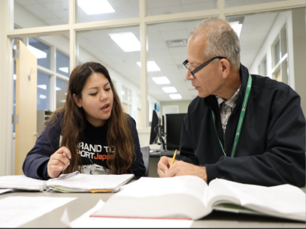
2. |  | 5 | 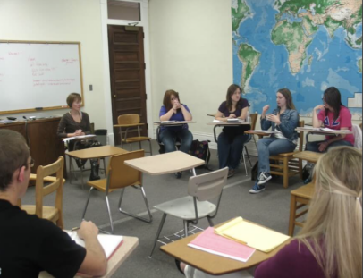
3. |  | 6 | 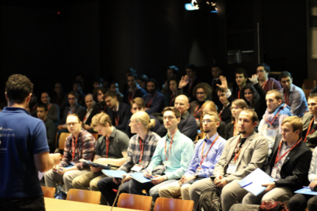
（图片来源于网络）

将单词（1-6） 和释义（a-f）配对
 | 1 | periodical | A | a long piece of writing on a particular subject
 | 2. | dissertation | B | an occasion when someone orders the return of a person who belongs to an organization
 | 3. | reference | C | a magazine or newspaper, especially on a serious subject, that is published regularly:
 | 4. | sociology | D | The study of the relationships between people living in groups, especially in industrial societies
 | 5. | renew | E | to begin doing something again
 | 6. | recalled | F. | A quick look at a book, piece of paper, etc. in order to find information and help.

Questions 21-25
Complete the summary below.
Write ONE WORD ONLY for each answer.
The School of Education Libraries
The libraries on both sites provide internet access and have a variety of 21...............materials on education.

The Castle Road library has books on sociology, together with 22............... and other resources relevant to the majority of 23...............school subjects.

The Fordham library includes resources for teaching in 24............... education and special needs.

Current issues of periodicals are available at both libraries, although 25............... issues are only available at Fordham.

Questions 26 and 27
Answer the questions below.
Write NO MORE THAN TWO WORDS AND/OR A NUMBER for each answer.

26 Which books cannot be renewed by telephone or email?
............... ............... ...............
27 How much time is allowed to return recalled books?
............... ............... ...............

记录下表关键词的同意替换
关键词 | 同意替换
a variety of | a range of
together with
majority of
include resources

Questions 28-30
Choose THREE letters, A-G.
Which THREE topics do this term’s study skills workshops cover?
A An introduction to the Internet
B How to carry out research for a dissertation
C Making good use of the whole range of library services
D Planning a dissertation
E Standard requirements when writing a dissertation
F Using the Internet when doing research
G What books and technical resources are available in the library

CI B1 U6

将下列单词与同意替换配对
1.criteria | 3. gender | 5. biography
2.crisp | 4. fame | 6.seminar

- workshop
- male or female
- standard
- snacks
- the story of a life about a person
- reputation

Questions 1-4
What helped each person to become successful?
Choose FOUR answers from the box and write the correct letter, A-F, next to Questions 1-4.
People
1.the film maker 3 the scientist
2 the ballet dancer 4 the chef

Reasons for Success  - a personal style  - a lot of money  - a relative's influence | - an invention  - a wise decision  - a change of job

Questions 5-10
Choose TWO letters, A-E.
Questions 5-6
Which TWO criteria will the students use to choose a successful person?
A age
B gender
C individual talent
D fame
E global importance

Questions 7-8
Which TWO things do the students agree to do before they meet again?
A write a biography
B conduct more research
C find photographs
D write a talk
E plan a seminar

Questions 9-10
Which TWO things do the students agree are linked to success?
A wealth
B experience
C talent
D effort
E location

知识点1：
Pick from a list
读题时划好题目中的_______
听前迅速读完_______
注意题目要求的_________

CI B1 U9
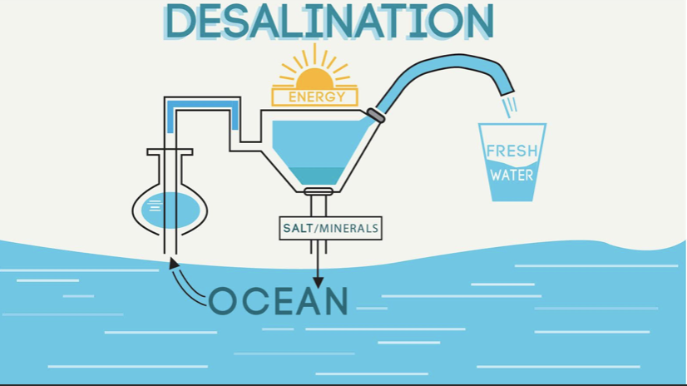
将以下单词与单词释义连线
单词 | 释义
filter (v.) | a. an artificial river built for boats to travel along or to take water where it is needed
canal (n.) | b. a solid, liquid or gas
pressure (n.) | c. to pass a liquid or gas through a piece of equipment in order to remove solid pieces or other substances
substance (n.) | d. found in the sea or relating to the sea
marine (adj.) | e. the force that you produce when you push something

Questions 1-5
What comment does the tutor make about each part of the presentation?
Write the correct letter, A-C, next to Questions 1-5.
NB You may use any letter more than once.
Parts of Presentation
- the introduction
- the background
- the description of the process
- the advantages/disadvantages
- the conclusion
Comments
A It needs to be shorter.
B The ideas are difficult to follow.
C Some information should be added.

Questions 6-10
Complete the flow chart below.
Write NO MORE THAN TWO WORDS for each answer.
The desalination process
Introductory point: a 6 ____________can desalinate sea water using its throat.

Collection: sea water passes through a canal into the 7______________

Treatment: rubbish is removed.

Salt removal: sea water passes through a membrane under high pressure; a very 8_____________process.
'

Produces fresh water and salty brine - can harm 9________________

Use: human consumption and irrigating 10____________

Answers
21. reference
22. textbooks
23.secondary
24. primary
25. back
26. overdue books
27. 7 working days
28-30 CEF

            - C
            - A
            - E
            - D
5-6 BE
7-8 BC
9-10 CD

            - C
            - B
            - A
            - B
            - C
6. Sea bird
7. Plant
8. Expensive
9. Marine life/ fish
10. Farmland

